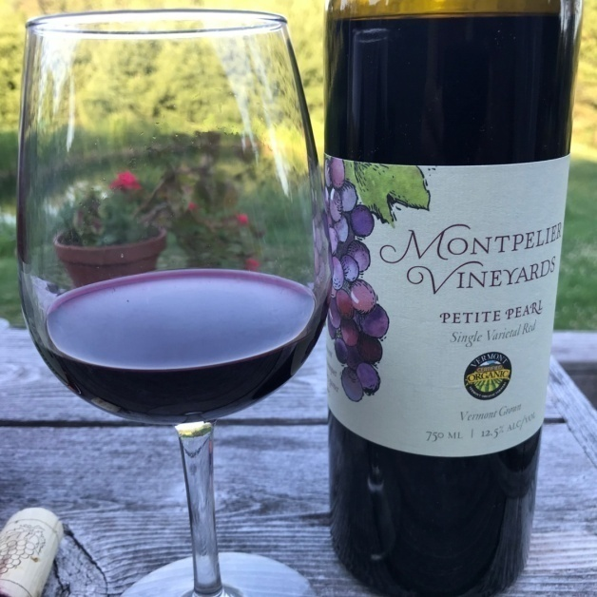
PETITE PEARL
SINGLE VARIETAL RED WINE

Vintage: 2021

Grape Variety: 100% Petite Pearl

Region: Montpelier, Vermont

ABV 12 ½% pH 3.35 T.A 6.75 g/L RS 2.5 g/L

Tasting Notes: The 2021 Petite Pearl is a garnet colored wine, almost opaque from the depth of color. The nose exhibits dark fruits, vanilla, and lilac alongside some slight minerality. On the palate strong jammy flavors of a variety of small fruits such as currants, cherries, and raspberries are complimented by vanilla, oak, and earthy richness. An initially creamy mouthfeel transitions into a tart and tannic aftertaste that leaves you wanting another sip.
Winemaking Notes: 2021 was a perfect year to grow grapes in Vermont. A warm dry spring and a hot summer led to a record yield and outstanding Brix numbers. Primary fermentation took place in stainless steel for two weeks followed by four months in virgin 112L Hungarian oak barrels. The wine finished secondary fermentation and aging in glass demijohns before bottling.

Total Production: 22 cases
