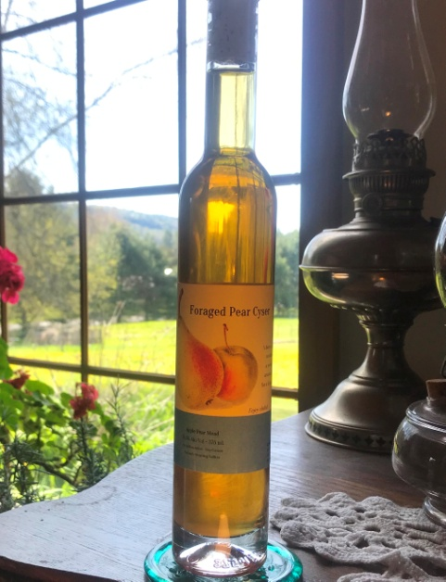
Pear Cyser

Vintage: 2021

Cider: Feral Pears and Wild Apples

Honey: Raw Wildflower - Northwoods Apiaries

Region: Vermont

Alcohol: 11.5 %

Winemaking Notes: Feral Pears and Wild Apples were pressed in October, mixed with the honey, and naturally fermented using the wild yeast on the fruit. After fermentation, the wine was aged in glass demijohns for six months before it was bottled.

Tasting Notes: Aroma is fruity and sweet, reminiscent of fruity pebbles, similar to an apple tree at full bloom. Slight spice and tropical fruits, caramelized sugar, and apple and pear flavors are present on the palate. Slightly detectable banana notes make it similar to bananas foster. Coupled with a silky, sweet, mouth feel, and a clean finish of pear and pineapple, this is an excellent and complex dessert wine. Serve at cellar temperature (55°F)
Total Production: 20 cases

