Supramolecular Lego with Cucurbiturils and Lanthanides
Eric Massonª

ª Department of Chemistry and Biochemistry, Ohio University, Athens, Ohio 45701, USA
E-mail: masson@ohio.edu

We will show first that a selection of alkali-, alkali-earth and lanthanide cations mediate the aggregation of Cucurbit[7]uril (CB[7]) complexes into well-defined trimers in solution, as long as (1) the solvent is dimethyl sulfoxide (and not water), and (2) the cavity of CB[7] is filled with a guest that leaves one carbonylated portal available for cation binding. In other terms, the CB[7]/guest trimer acts as a cryptand with exceptional affinity to the cations in dimethyl sulfoxide. We will then show that the binding selectivity of CB[n]s (n = 5 – 8), at least when guests are hydrocarbons or noble gases, can be predicted by mimicking the macrocycles with hard-sphere fluids with low polarities and low polarizabilities and “pre-formed” cavities. The importance of dispersive interactions in aqueous host-guest recognition will also be highlighted using a Cucurbituril-based supramolecular balance. We will conclude on a different note, with our latest advances towards the synthesis and manipulation of lanthanide-based assemblies on surfaces.

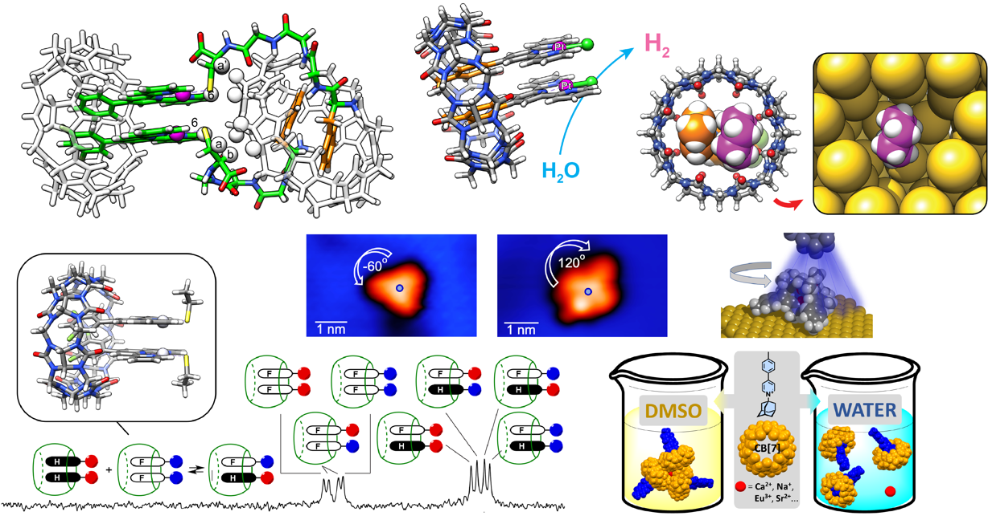

References
- Characterization of just one atom using synchrotron X-rays – Ajayi, T. M.; Shirato, N.; Rojas, T.; Wieghold, S.; Cheng, X.; Latt, K. Z.; Trainer, D. J.; Dandu, N. K.; Li, Y.; Premarathna, S.; Sarkar, S.; Rosenmann, D.; Liu, Y.; Kyritsakas, N.; Wang, S.; Masson, E.; Rose, V.; Li, X.; Ngo, A. T.; Hla, S. W.; Nature 2023, 618, 69 – 73.
- Atomically precise control of rotational dynamics in charged rare-earth complexes on a metal surface – Ajayi, T. M.; Singh, V.; Latt, K. Z.; Sarkar, S.; Cheng, X.; Premarathna, S.; Dandu, N. K.; Wang, S.; Movahedifar, F.; Wieghold, S.; Shirato, N.; Rose, V.; Curtiss, L. A.; Ngo, A. T.; Masson, E.; Hla, S. W. Nat. Commun., 2022, 13, 6305.
- Solvent-controlled formation of alkali and alkali-earth-secured Cucurbituril/guest trimers –Lončarić, D.; Movahedifar, F.; Radek Štoček, J.; Dračínský, M.; Cvačka, J.; Guan, S.; Bythell, B. J.; Císařová, I.; Masson, E.; Kaleta, J.; Chem. Sci. 2023, DOI: 10.1039/d3sc02032k.
- Cucurbiturils mimicked by low polarizability solvents with pre-formed cavities: an empirical model to predict hydrocarbon selectivity – Rabbani, R.; Nazimuddin, Md; Barbero, H.; Masson, E. Chem. Sci., 2022,13, 4388-4396.
- Enhanced photoreduction of water catalyzed by a cucurbit[8]uril-secured platinum dimer – Rabbani, R.; Saeedi, S.; Nazimuddin, Md.; Barbero, H.; Kyritsakas, N.; White, T. A.; Masson, E. Chem. Sci. 2021, 12, 15347 – 15352.
- Design and Recognition of Cucurbituril-secured Platinum-bound Oligopeptides – Barbero, H.; Masson, E. Chem. Sci., 2021, 12, 9962 – 9968.

