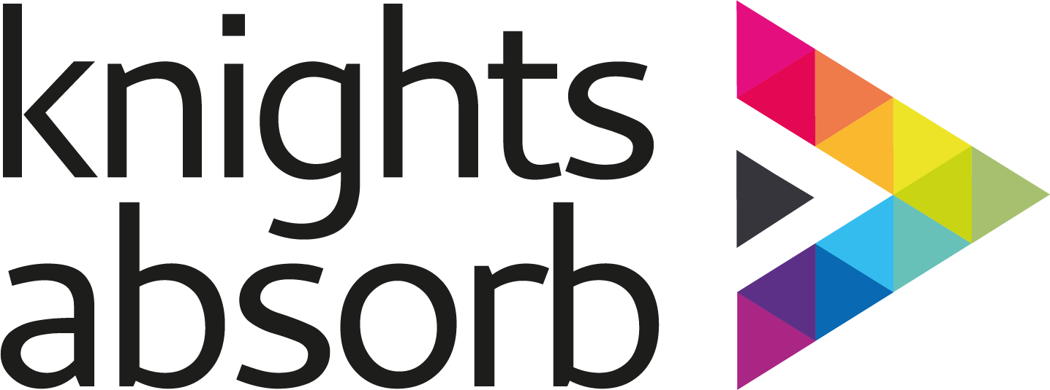

Equality, Diversity and Inclusion

COURSE TITLE
Equality, Diversity and Inclusion

OVERVIEW OF COURSE AIMS
For learners to explore definitions and examples of equality and diversity and organisational culture. This course will also raise awareness around unconscious bias to help improve management and professional development of self and other colleagues.
Progression Course(s):
Change Management Lawful and Effective Human Resource Management (with coursework)

HOW LONG DOES THE COURSE LAST
This is the total onsite duration and does not include any pre or post work, if applicable
This course is delivered over a full day (6 hours) for leaders and managers or a condensed half day (3 hours) for frontline staff.

WHO SHOULD ATTEND
All professionals within the health and social care industry.

DELEGATE NUMBERS
This ensures adequate time is allocated for each delegate
Any changes to these numbers must have prior approval from Knights Agency
Minimum: 5
Maximum: 10 Remote

COURSE CONTENT
This is the standard criteria covered but can be adapted to suit each client
Definitions of equality and diversity and inclusion
Principles of assumption and unconscious bias
Protected characteristics
Barriers to inclusion
Case studies
Best Practice - taking positive action
Legislation and implications
Learning assessment

BY THE END OF THE COURSE LEARNERS WILL...
This is the standard criteria covered but can be adapted to suit each client
Establish a common understanding of the importance of equality, diversity and inclusion and consider current mind set.
Know how to work in an inclusive way and explore principles around unconscious bias as a way to raise its awareness.
Know how to access information, advice and support about diversity, equality, inclusion and discrimination.
To understand how current key government and local policy can aid best practice for an organisation and its employees.
CERTIFICATE INFORMATION

CERTIFICATE VALIDITY
Knights recommendation is for a refresher at least every 12 months
3 years

CERTIFICATE TITLE
This information will be displayed on the delegates certificate
Equality, Diversity and Inclusion

CERTIFICATE AIMS
This information will be displayed on the delegates certificate
Able to establish a common understanding of the importance of equality, diversity and inclusion and consider current mind set.
Know how to work in an inclusive way and explore principles around unconscious bias as a way to raise its awareness.
Know how to access information, advice and support about diversity, equality, inclusion and discrimination.
Understand how current key government and local policy can aid best practice for an organisation and its employees.
COURSE TIMINGS

GLH
Guided Learning Hours
3 or 6 hours

