**Organic Electronics – From the Research Lab into the Classroom**

Amitabh Banerji 1

*1 University of Potsdam, Chemistry Education, Germany*

To prepare students for a life in an increasingly technology dominated world and to motivate them for STEM (science, technology, engineering, mathematics) it is crucial to implement cutting-edge research and future technologies into the science curriculum of schools and universities. Our group has a long-lasting expertise in introducing recent scientific developments, i.e. semiconductors based on organic and perovskite materials into the curricula of German schools and universities, following the principles of Curriculum Innovation [1].

Organic semiconductors are a new class of materials representing an innovative field of scientific research. Efficient illuminants, such as organic light emitting diodes (OLEDs) can be found in ultra-thin and super-bright displays of modern high-tech applications. Organic Photovoltaic cells (OPV) can be produced as light weight, super-thin, flexible and semi-transparent films, which can be embedded into the windows and facades of modern buildings.

In my talk, I will discuss the theoretical basics of organic electronics and I will demonstrate the low-cost fabrication of a DIY-OLED and a DIY-OPV-cell [2] in a live demo (fig. 1).

**Science can be so much fun!**

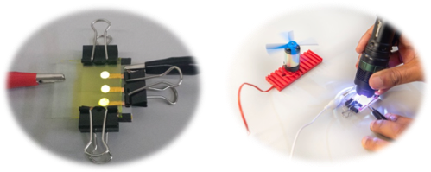

Figure 1: low-cost DIY-OLED (left) and DIY-OPV-cell (right)

**References:**

[1] M. W. Tausch, *PdN-ChiS,* ***2004***, *53(8)*, 18–21

[2] A. Banerji, *Nachr. Chem.* **2017**, *65(7/8)*, 807–809

[3] V. Meggyes, A. Banerji, *Nachr. Chem.* **2023**, *71(6)*, 15–18